

TECH SAKSHAM

Final Project Report

Full Stack Web Development

Dr.B.R.Ambedkar University, Srikakulam.



|  |  |
| --- | --- |
| **ROLL NO** | **NAME** |
| **1981951016** | **K.V.LAASYA SRI** |
| **1981951029** | **M.JANSHI** |
| **1981951025** | **M.SAI TEJA** |

ABSTRACT

Hangman is a popular word guessing game where the player attempts to build a missing word by guessing one letter at a time. After a certain number of incorrect guesses, the game ends and the player loses. The game also ends if the player correctly identifies all the letters of the missing word.

INDEX

|  |  |  |
| --- | --- | --- |
| S.No. | Table of Contents | Page No. |
| 1 | Chapter 1: Introduction | 4 |
| 2 | Chapter 2: Tools Required | 5 |
| 3 | Chapter 3: Architecture | 6 |
| 4 | Chapter 4: Rules | 8 |
| 5 | Chapter 5: Conclusion | 9 |
| 6 | Chapter 6: Reference | 10 |
| 7 | Chapter 7: Code | 11 |

**INTRODUCTION**

Hangman is a classic word-guessing game. Players attempt to guess a hidden word by suggesting letters within a certain number of attempts.

One of strategies to teach English is by using game. Game is an activity with rules, a goal and an element of fun(Hadfield, 1998). In other words, game is one of interesting strategies to teach the students and it also have some purposes and steps. By using game, teaching learning activity will be more fun. And students will have an interest to learn the material. Also students will understand about the material easily.

**TOOLS REQUIRED**

The Hyper Text Markup Language or HTML is the standard markup language for documents designed to be displayed in a web browser. It is often assisted by technologies such as Cascading Style Sheets (CSS) and scripting languages such as JavaScript.

  

JavaScript (JS) is the most popular lightweight, interpreted compiled programming language. It can be used for both Client-side as well as Server-side developments. JavaScript also known as a scripting language for web pages.

Cascading Style Sheets is a style sheet language used for describing the presentation of a document written in a markup language such as HTML or XML

**ARCHITECTURE**

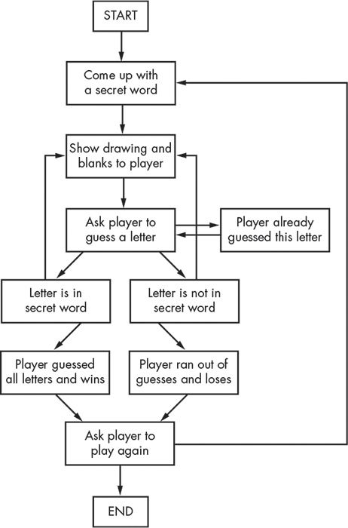

STEPS TO PLAY HANGMAN GAME

There are some steps to play Hangman Game:

1. Draw some rows representing the number of the letters in a vocabulary words.
2. Have the students guessing the letter.
3. If the letter is in the word, write the letter in the appropriate row.
4. If the letter is not in the word, then draw the hanged man (1-head, 2- torso, 3-arm, 4-arm, 5-leg, 6-leg).
5. If they can guess the word before the drawing of hanged man is done, then they win.

**RULES**

1.One player thinks of a word and marks the

number of letters with dashes.

2.The other player guesses letters one at a

time.

3.If a guessed letter is in the word, it gets

filled in the corresponding blank(s),

otherwise, the other player draws one part

of the hangman.

**CONCLUSION**

A great deal was learned from the process of coding the hangman game, especially when it comes to problem solving. First, what worked best when trying to fix a bug in the code, it is crucial to first identify the source of the bug. This can be difficult sometimes when there are many lines of code, but if the problem is to be solved as fast as possible, this is the first thing to be done. This principle can also be applied to many other aspects of engineering as well.

**REFERENCE**

Pisheh, Najmeh M. and Bagheri, M. Sadegh (2012). The Impact of ducational Games on Vocabulary and Grammar Learning of Elementary Iranian EFL Learners. Iranian EFL Journal Vol. 8 Issue 6 December 2012.

Rauschenberg J. (2005). Classroom Games: Effective Tools

Mayer-Johnson LLC. (2010). The Picture Communication Symbol.

Hackman, Sue (2008). Teaching Effective Vocabulary. Department for Children, Schools, and Families.

Hadfield, J. (1998). Elementary Vocabulary Games. Longman.

**CODE**

[HANGMAN-GAME/HANGMAN GAME at main · Laasya-Sri/HANGMAN-GAME (github.com)](https://github.com/Laasya-Sri/HANGMAN-GAME/tree/main/HANGMAN%20GAME)